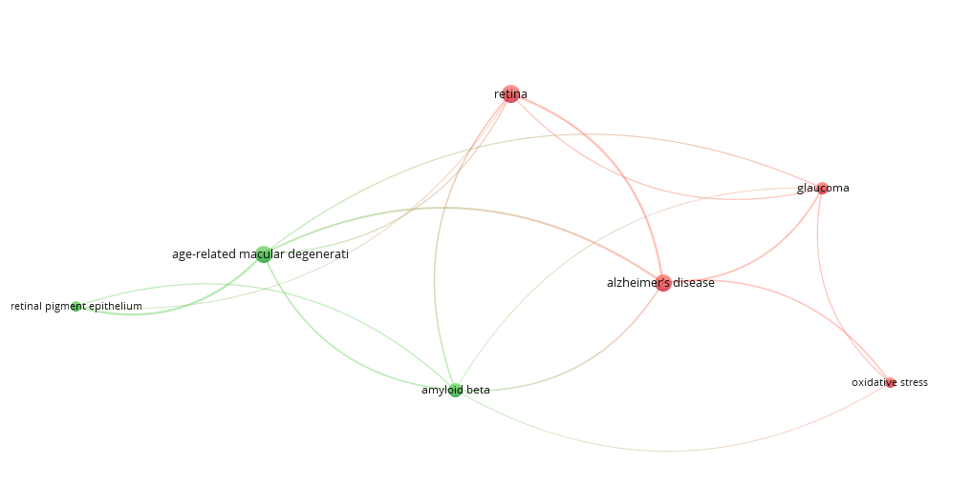**Supplementary figure 1.** Mapping for keywords appearing more than 10 times in ophthalmology articles discussing amyloid beta, where the size of each entity represents higher or lower number of appearances.

Supplementary table 1

|  |  |  |  |  |  |  |  |
| --- | --- | --- | --- | --- | --- | --- | --- |
| **Table 1.** Summary of ophthalmology related papers citing Lense et al 2006 publication | | | | | | | |
| Reference | Objective/Research Question | Methodology/Design | Related Eye Diseases | Major Findings | Aβ role | Implications for ophthalmology | Recommendations for Future Research |
| Hoh Kam et al., 2010 39 | Demonstrating site specific age-related accumulation of Aβ in the normal mouse retina | Lab experiment on mice | AMD | Aβ depositions progress with age and could be found not only at Bruch’s membrane and along blood vessels, but also coating photoreceptor outer segments | Aβ accumulation causes RPE alterations and activates the complement  Cascade, microglia, astrocytes and dendritic cell leading to retinal  degeneration | Providing quantitative measurements for the different locations of Aβ depositions in retina. | __ |
| Isas et al.,  2010 40 | Searching for different amyloid structures in eye drusen | Lab experiment on human tissue | AMD | Wide spectrum of Amyloid structures can be found in drusen from non-fibrillar oligomers till amyloid fibrils. | Aβ nonﬁbrillar oligomers are described as the toxic form of Aβ without reporting their role | Drusen in eyes contain Aβ depositions which can be used for both diagnostic and therapeutic approaches | Searching for the role behind nonﬁbrillar oligomer toxicity |
| Begum et al., 2013 41 | Preventing AMD mitochondrial function decline using 670 nm light | Lab experiment on mice | AMD | Increase in COX, decrease in C3, decrease in vimentin and GFAP expression | No effect on Aβ deposition | Therapeutic Potential of 670 nm Light in reducing inflammation and treating AMD | Investigate longevity of therapy impact and effects of chronic exposure on eyes |
| Masuzzo et al.,  2016 19 | Discussing some pathological aspects  related to Aβ deposition in the nervous system | A literature review | AMD, Glaucoma | Retina maybe the "window to brain" as a possible source for diagnostic biomarkers for neuro degenerative diseases. | Aβ in eyes like in brain lead to synaptic dysfunction, mitochondrial failure, glial activation, and vascular abnormalities | Understanding pathological roles of Aβ in eyes and the retina as a possible source of diagnostic biomarkers | Assessing the relationship between Aβ and other neurodegenerative disease such as PD |
| Naaman et al.,  2020 38 | Is Aβ toxic to the retina and which Aβ species are responsible for the pathogenesis? | Lab experiment on rats | AMD | Oligomeric Aβ42 is the major toxic amyloid species, fibrillar Aβ42 showed lesser toxicity, while Aβ40 fibrils didn’t show any toxic effect | Oligomeric Aβ42 lead to significant decrease in ERG readings showing a major toxic effect | Oligomeric Aβ42 could be a target for future therapy and/or a diagnostic biomarker. | Studying the chronic toxic effect of AB on retinal degeneration to understand AMD more |
| Bartley et al., 2022 42 | Are AβOs involved in the neurodevelopment of normal retina? | Lab experiment on chicks | AMD, Glaucoma | AβOs are expressed in developing retinas with minimum of four different proteoforms | AβOs are required for the tissue development of retinal layers | AβOs are essential for retina development, targeting them for therapy should be reconsidered | Investigating the regulatory mechanisms of AβO production and trafﬁcking in retina |
| Moncaster et al.,  2022 43 | How does AD affect the lens of the eye? | Lab experiment on mice and human tissue | Cataract | Aβ depositions of AD induce structural deformations in lenses causing different forms of cataract in eyes | Aβ peptides bind αB-crystallin forming pathological microaggregates that scatter light | Aβ pathology in lenses could be an early predictor for AD | Further studies on using Aβ in lenses as a diagnostic factor for AD are needed |
| Abbreviations: Aβ, Amyloid beta; AMD, Age-related Macular Degeneration; RPE, Retinal Pigment Epithelium; COX, cytochrome c oxidase; GFAP, glial fibrillary acidic protein; PD, Parkinson's disease | | | | | | | |